SA school students accept Federal Budget deficit needed in fight against COVID
They’ll be paying tax to cover the massive federal deficit for years into their working life. But these SA students accept it must be done.
They are the next generation of voters – and the people who will most likely have to pick up the tab of federal government debt that will soon blow out to $1 trillion.
But a group of Year 12 students at Marryatville High were unperturbed by the looming repayments – accepting that large spending is required to keep Australia’s economy afloat through the coronavirus pandemic.
Treasurer John Frydenberg announced on Tuesday night that the federal government’s net debt would grow to $729bn next financial year, before climbing to nearly $1 trillion in 2024-25.
Students Audrey Jones, Panae Parhas, Leo Zimmermann and Hayley Waterman said they were mildly concerned about the projected debt but believed it was necessary for the good of the country.
“I think, as young people and in this time, we’re kind of used to this kind of change,” Audrey, 17, said.
“COVID has thrown a spanner in the works so we’re used to it.”
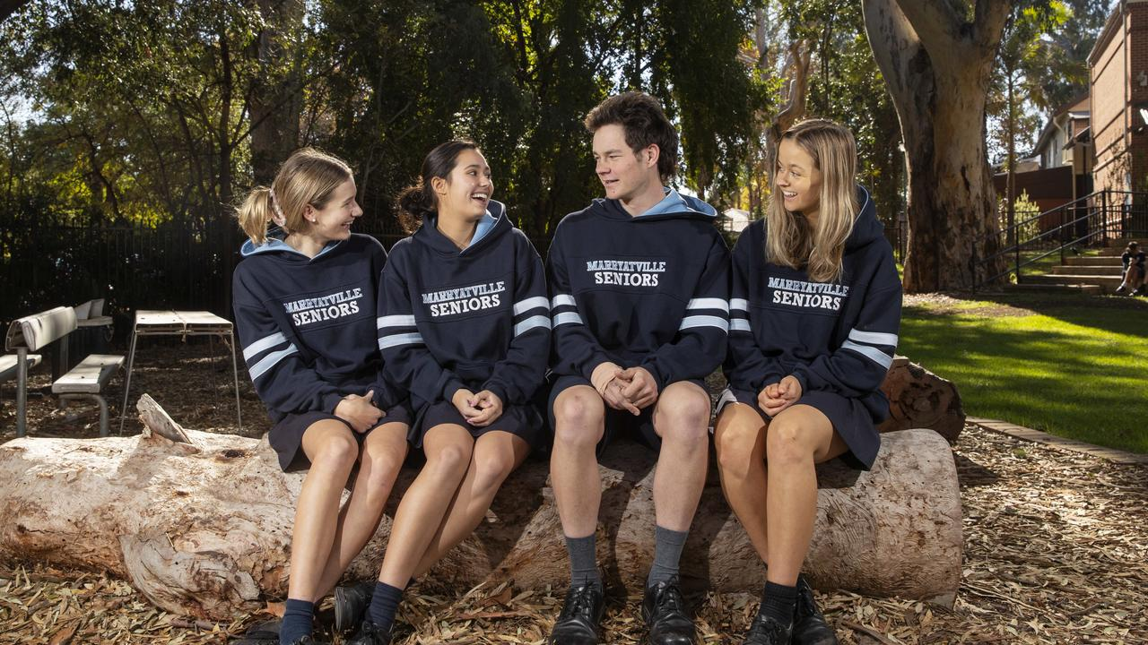
Marryatville High students Audrey Jones, Panae Parhas, Leo Zimmermann and Hayley Waterman: “COVID has thrown a spanner in the works so we’re used to it.” Picture: Simon Cross
Leo, 17, said there was “always going to be an element of debt and something to pay back”.
But he said the response to COVID in Australia was “handled well and it was always going to have a cost”.
Hayley, 18, said: “The future of these debts is something Australia is always managing.”
The Marryatville students are ahead of the game in understanding how governments work and how citizens can make an impact. They took part in the pilot of a civic education program developed by the Commissioner for Children and Young People called yChange.
Panae said it gave teenagers an important background of how the world works.
“I never really got to sit down and have it explained that this is the (parliament) Speaker and this is their job,” the 17-year-old said.
“For young people, that’s really important.”
The yChange program was trialled over the past 18 months at Elizabeth Vale Primary School, Marryatville High and Mark Oliphant College ahead of a general release last week.
“Young people have told me they see themselves as a generation for change; that if given the chance they could have a positive impact on the world around them, both now and into the future, particularly within their own local communities,” Commissioner Helen Connolly said.
“Young people’s capacity for finding creative, innovative solutions to both big and small problems is untapped and should not be underestimated.”
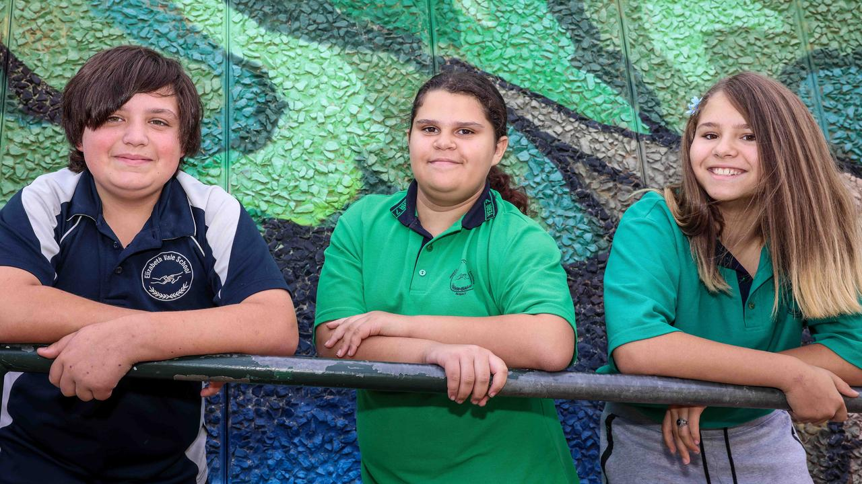
Elizabeth Vale Primary School students Xavier, Olivia and Debra took part in trialling the yChange program. Picture: Russell Millard
Elizabeth Vale strategic leader for Aboriginal education Vicki Wilson said students had been “quite chuffed” to be involved and have their ideas heard.
“They said they want their community to be a more inclusive place,” she said.
“They wanted more opportunities for leisure activity – like netball and footy.
“But they also wanted more support for older people.”
The program aims to complement existing school lessons about rights and responsibilities and civic structure, such a as the tiers of government.
The yChange program sets out five steps for students – identify an issue in the community that needs to be addressed, research it, create a plan, act on the plan and then communicate the outcome.
It complements the civics and citizenship strands of the Australian curriculum and aligns with the aims of South Australia’s Youth Action Plan.

